**Project Title:** **Eventify - Event Management System**

**Abstract:**

Eventify is an Event Management System designed using ASP.NET MVC, C#, and SQL Server. This system focuses on providing users with a platform to register, create private events, and participate in upcoming events. The administrator has the ability to manage admin events as well as user events, ensuring a seamless and engaging experience for both event creators and participants.

**Key Features:**

**1. User Registration and Authentication:** Users can create accounts securely and log in to access the system. Robust authentication mechanisms ensure a safe and protected user experience.

**2. Private Event Creation:** Registered users can create their private events, specifying details such as event name, date, hall, description, food etc.

**3. Admin Event Creation:** Admin can create admin events, for which users can buy tickets.

**4. Admin Dashboard:** Admins can create and manage admin events and private events.

**5. Event Participation:** Users can browse and participate in upcoming admin events like Music events, New Year celebrations.

**6. User Dashboard:** Users have personalized dashboards to track their registered events, upcoming participations, and private event creations.

Eventify aims to simplify the event management process, allowing users to create and participate in a variety of events while providing administrators with the tools needed for effective management.

**Project Goals:**

• To establish a user-friendly and effective online platform for event enthusiasts to engage in creating and participating in various events.

• To digitize and optimize the management of private and public events, enhancing the overall experience for both event organizers and participants.

• To ensure a secure and reliable system that prioritizes the confidentiality of user data.

**Technical Stack:**

• Frontend: ASP.NET MVC, HTML, CSS, JavaScript, Bootstrap

• Backend: C#, .NET Framework

• Database: SQL Server

The Eventify Management System is designed to elevate the online presence of events, fostering community engagement, and streamlining event-related operations. By leveraging technology and adopting a user-centric design, the system aims to provide an efficient and enjoyable experience for users involved in event creation and participation.

**DB Relational Schema:**

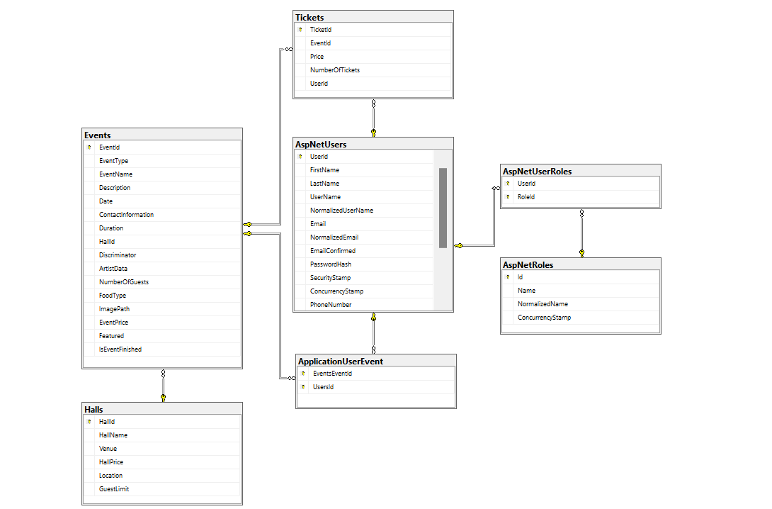

**Entity Relationship Diagram:**

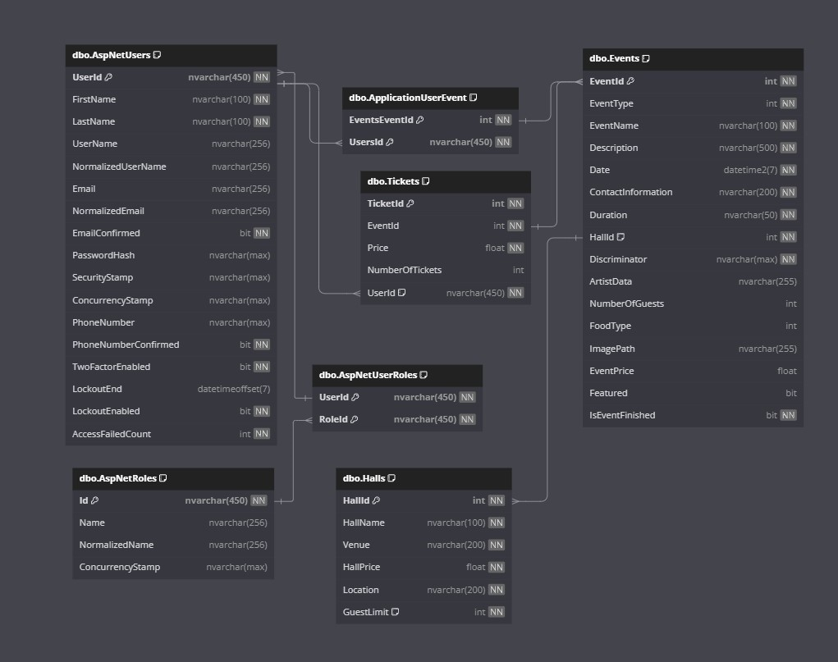

**Entity Relationship:**

1. **One-to-Many Relationship:**
   * Between Events and Halls: Each event can be associated with one hall, but a hall can host multiple events. This is represented by the foreign key Events.HallId referencing Halls.HallId.
2. **Many-to-Many Relationship:**
   * Between AspNetUsers and AspNetRoles: Each user can have multiple roles, and each role can be assigned to multiple users. This is represented by the junction table AspNetUserRoles, connecting the primary keys of both tables.
3. **One-to-Many Relationship (Bidirectional):**
   * Between Events and Tickets: Each event can have multiple tickets, but each ticket belongs to only one event. This is represented by the foreign key Tickets.EventId referencing Events.EventId.
4. **Many-to-Many Relationship (Bidirectional):**
   * Between AspNetUsers and Events: Each user can be associated with multiple events, and each event can have multiple users attending. This is represented by the junction table ApplicationUserEvent, connecting the primary keys of both tables.

**Data flow diagram:**

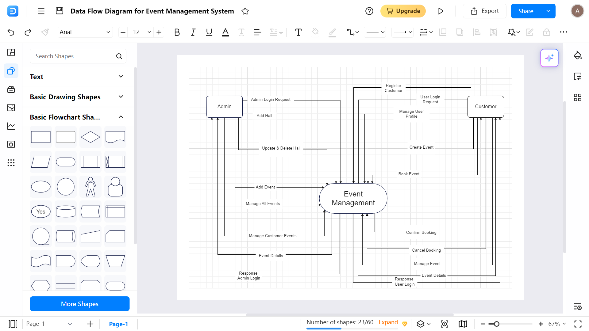

**High-Level Design Document: Eventify - Event Management System**

**1. Introduction**

Eventify is an Event Management System developed to provide users with a seamless platform for creating private events and participating in upcoming events. The system aims to enhance user engagement.

**2. Key Components**

* **User Management:** Enables user registration, login, incorporating robust authentication mechanism.
* **Event Creation:** Allows registered users to create private events, specifying details such as event type, date, hall, and description.
* **Event Participation:** Permits users to browse and participate in upcoming cultural and concert events.
* **Admin Event Management:** Provides administrators with a dashboard to manage private event creations, add and manage halls, admin events, view and manage user participation in admin events.

**3. Database Design**

The database design includes the following tables:

1. **AspNetUsers:** Stores user account information such as:
2. **Events:** There are two types of events distinguished by the Discriminator column:
   * Admin Events: Events organized by administrators.
   * Private Events: Events organized by users.
3. **ApplicationUserEvent:** Junction table linking users to events.
4. **Halls:** Stores information about different halls available for events.
5. **Tickets:** Stores information about tickets purchased for events.
6. **AspNetRoles:** Stores information about roles in the system.
7. **AspNetUserRoles:** Junction table linking users to roles.

**4. Technologies Used**

* **Frontend**: ASP.NET MVC, HTML, CSS, JavaScript, Bootstrap.
* **Backend**: C#, .NET Framework.
* **Database**: SQL Server.

**5. Deployment**

Eventify can be deployed on a web server supporting ASP.NET applications.

**Login and Registration UI:**

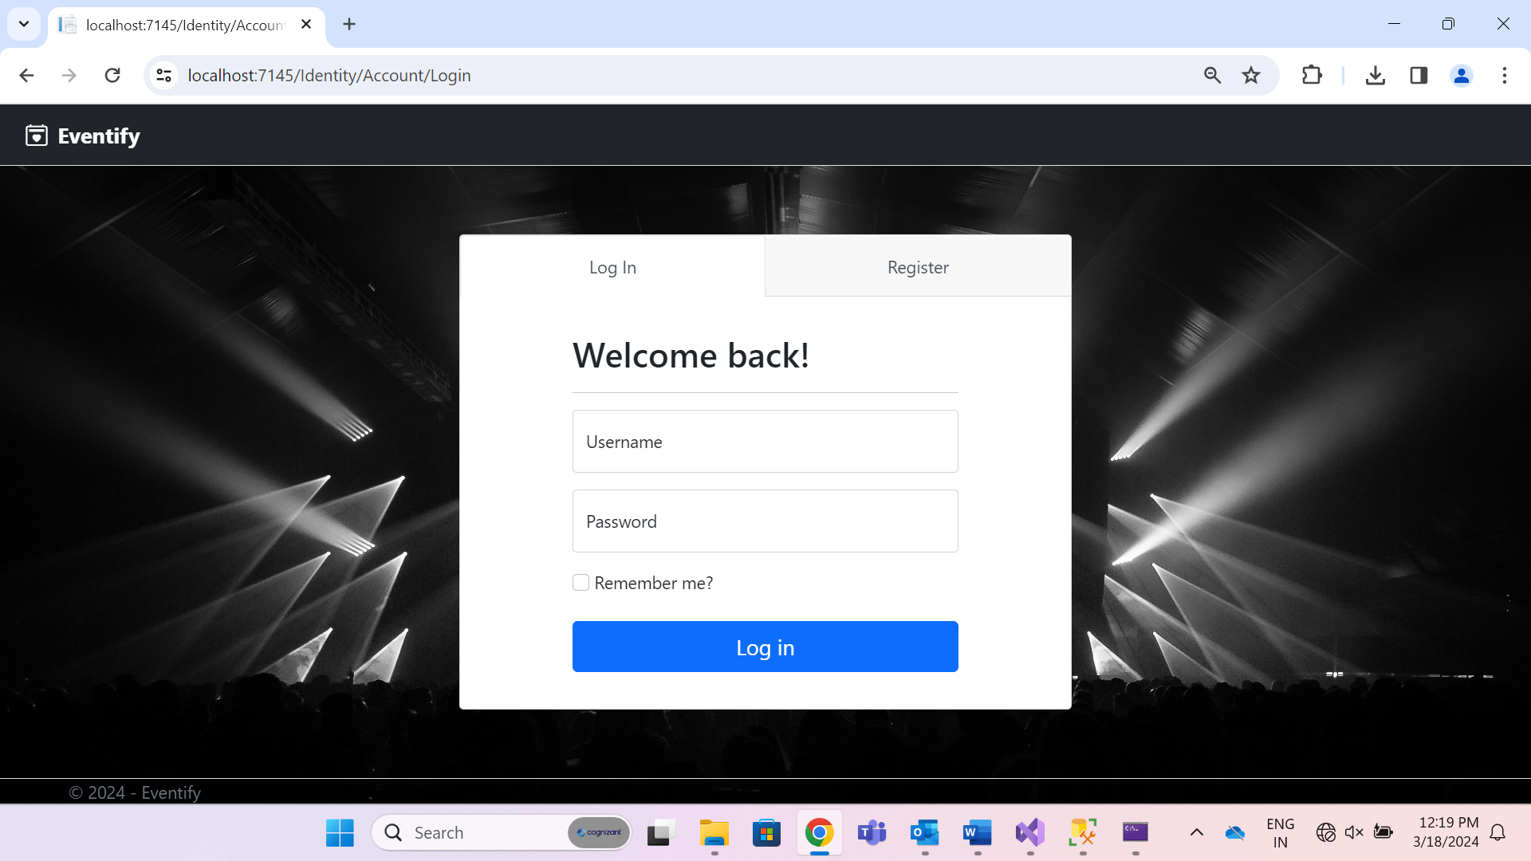

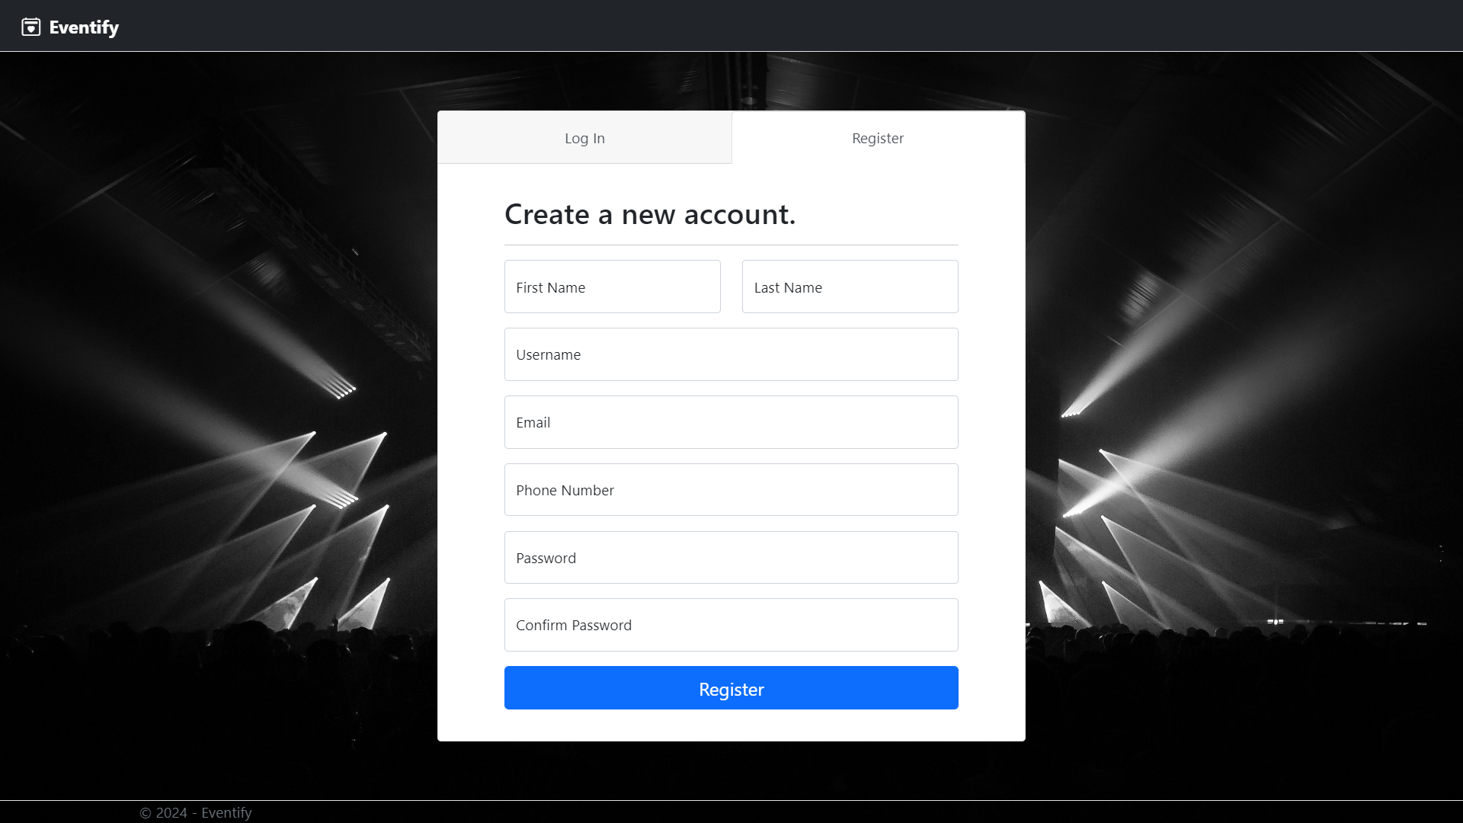

**Wireframes:**

**Wireframe 1: Home Page**

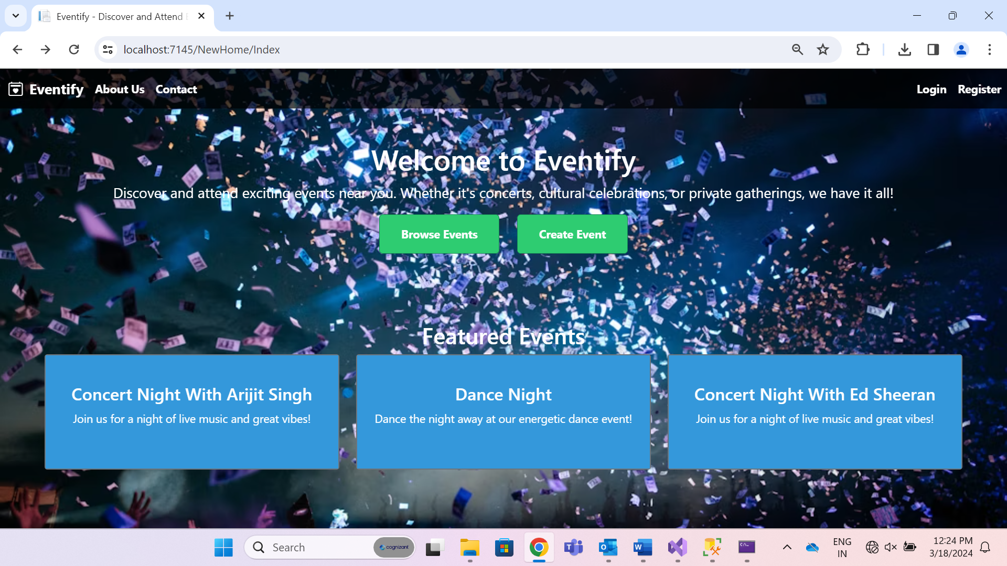

* **Header:** Includes the platform logo, navigation menu, and user login/register links.
* **Browse Events:** Displays different admin organized events.
* **Create Event:** Lets you organize your own private event.
* **Featured Events Section:** Showcases featured upcoming events with brief descriptions.

**Wireframe 2: Browse Event Page**

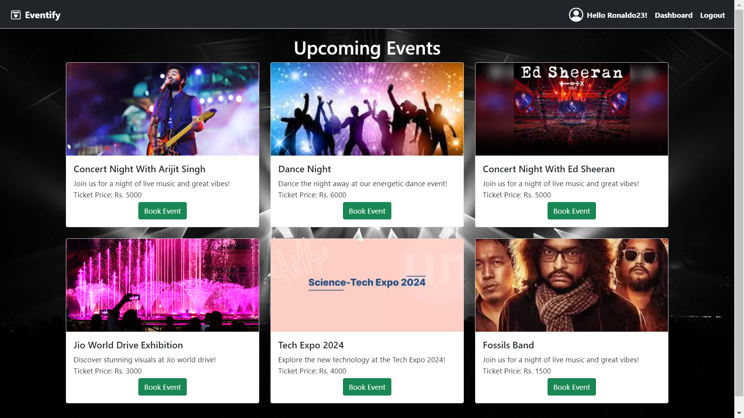

* **Event Image:** Showcases an image related to the event, a poster or banner.
* **Book Event:** Allows users to buy tickets for event.

**Wireframe 3: Private Event Creation Page**

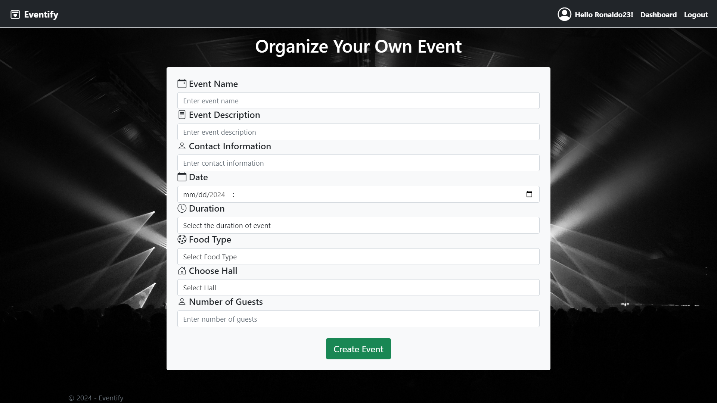

* **Event Details Form:** Includes fields for specifying event details like date, number of guests, and hall selection.
* **Food Selection:** Allows users to select the preferred food type for the event.
* **Create Event Button:** Finalizes the private event and shows the booking receipt.

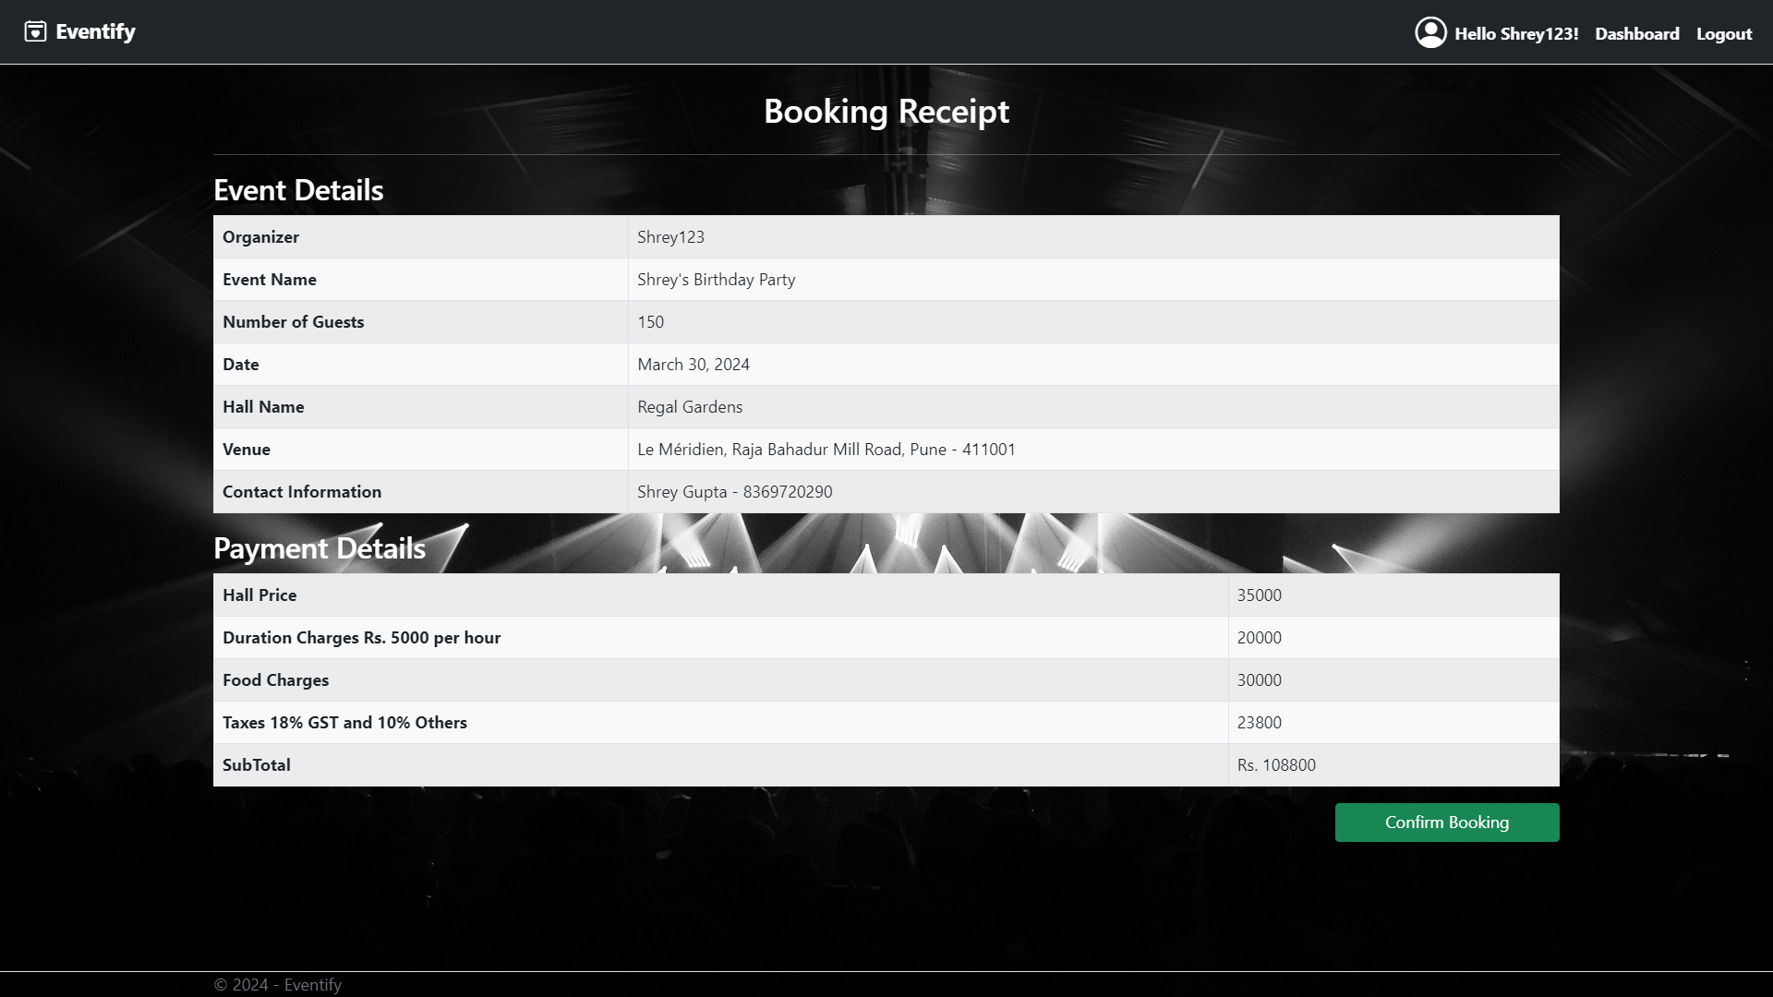

* **Confirm Booking Button:** Confirms and creates the booking.

**Wireframe 4: User Dashboard**

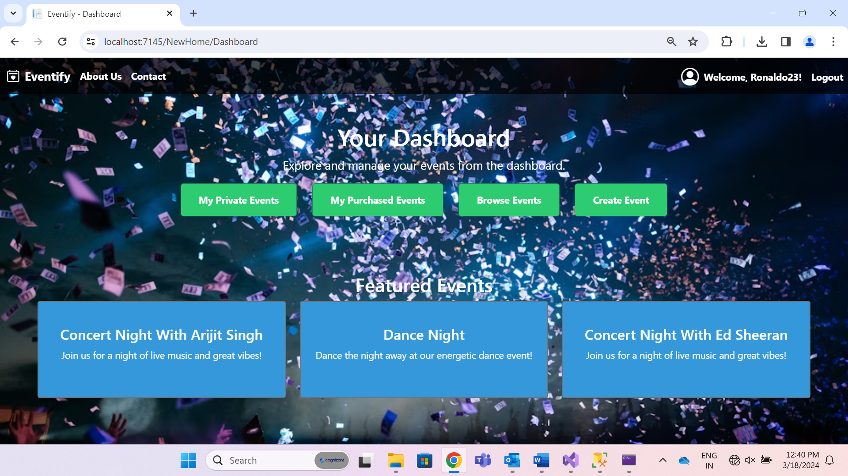

* **Header:** Includes the platform logo, navigation menu, and user logout.
* **My Private Events:** Lists events the user has created.
* **My Purchased Events:** Lists events that user bought tickets for.
* **Browse Events:** Displays different admin events.
* **Create Event:** Let users organize their own event.
* **Featured Events Section:** Showcases featured upcoming events with brief descriptions.

**Wireframe 5: User Organized Events**

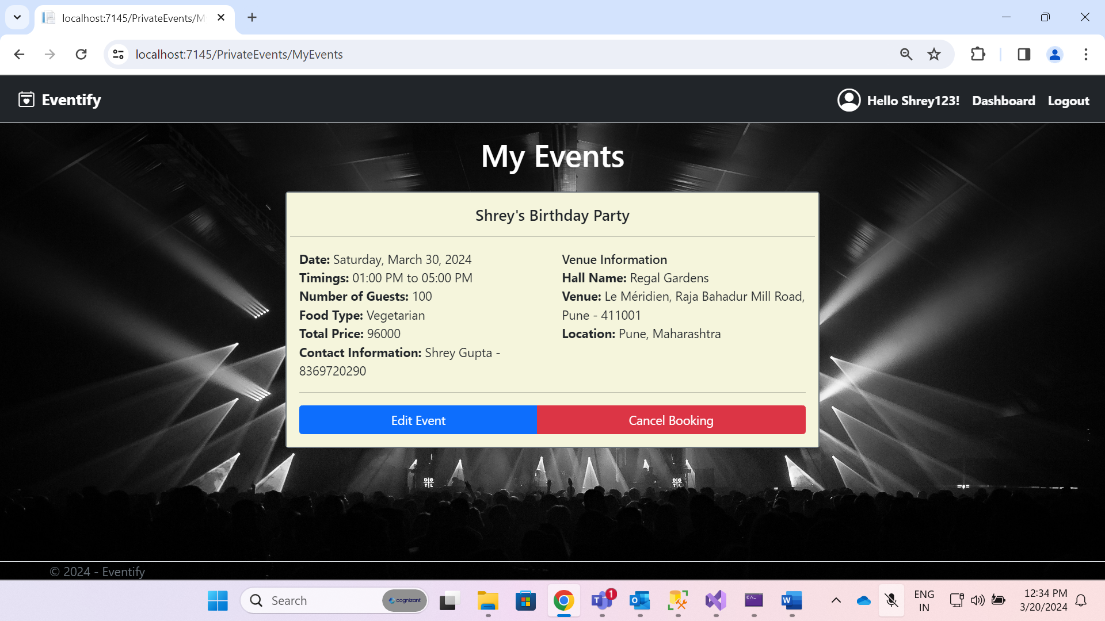

* **Edit Event:** Allows user to edit event.
* **Cancel Booking:** Allows user to cancel event.

**Wireframe 6: User Purchased Events**

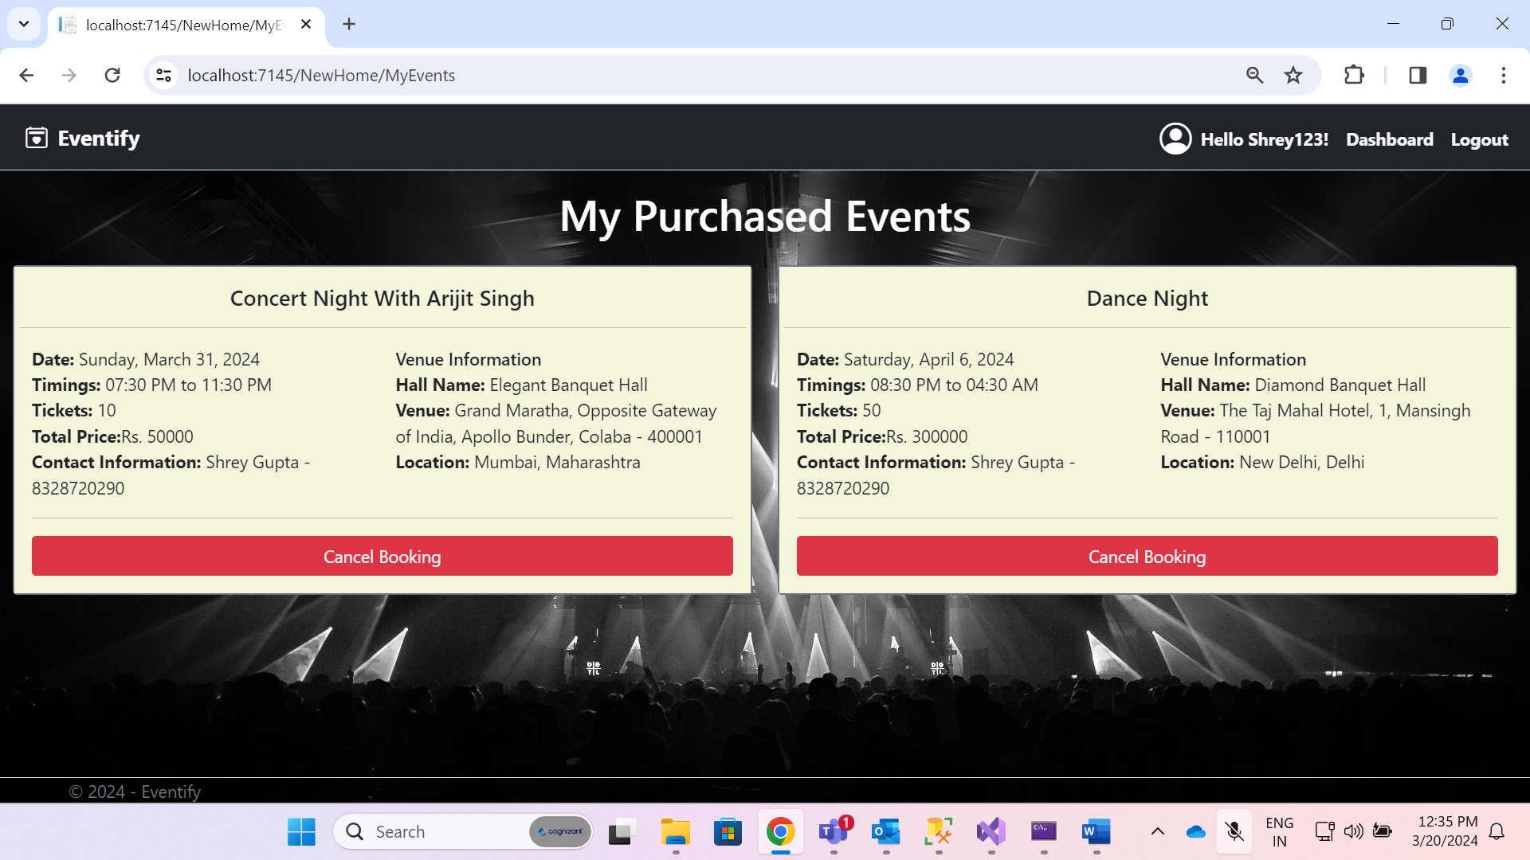

* **Cancel Booking:** Allows user to cancel booking for the event.

**Wireframe 7: Admin Dashboard**

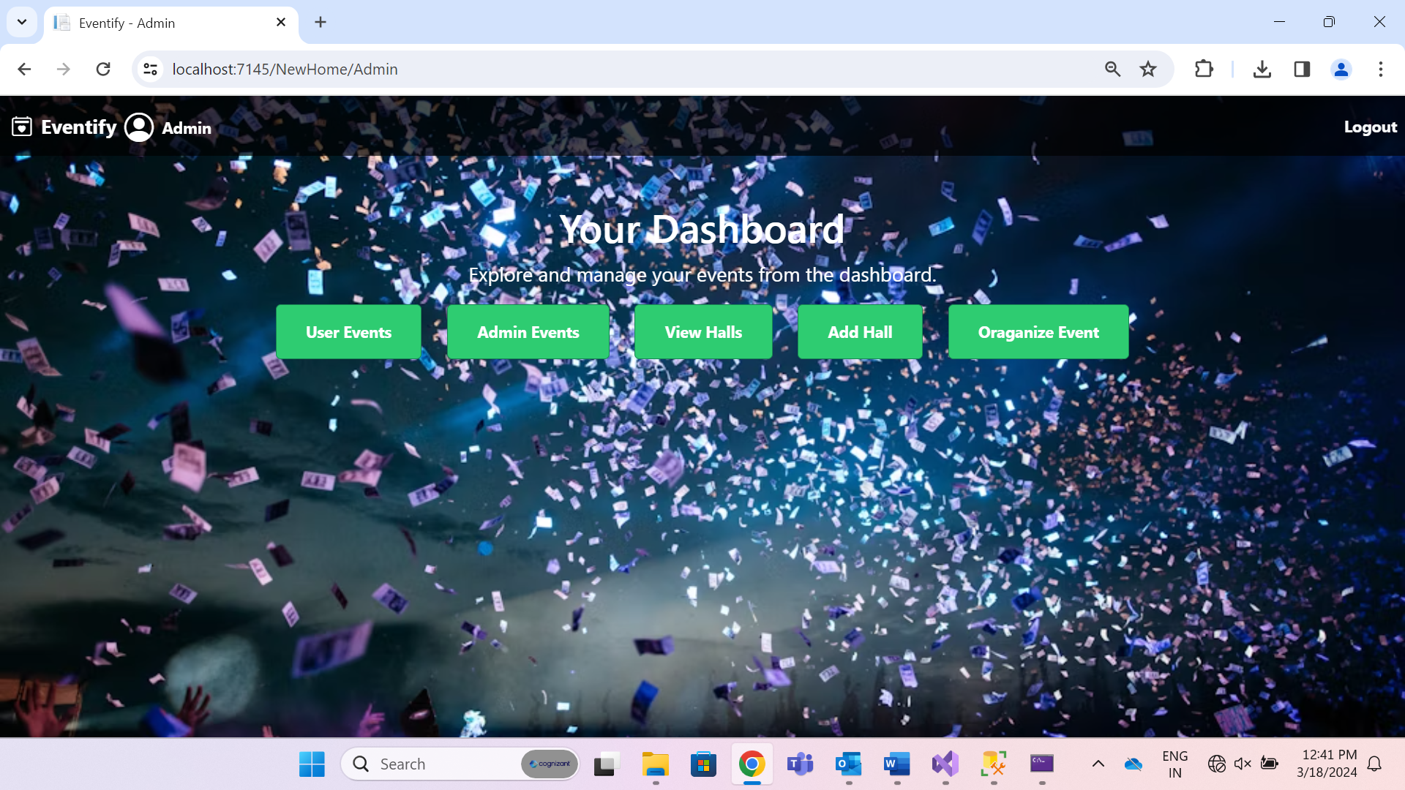

* **Manage Events Section:** Provides administrators with tools to manage private events, edit delete event requests, and view event details.

**Wireframe 8: User Events**

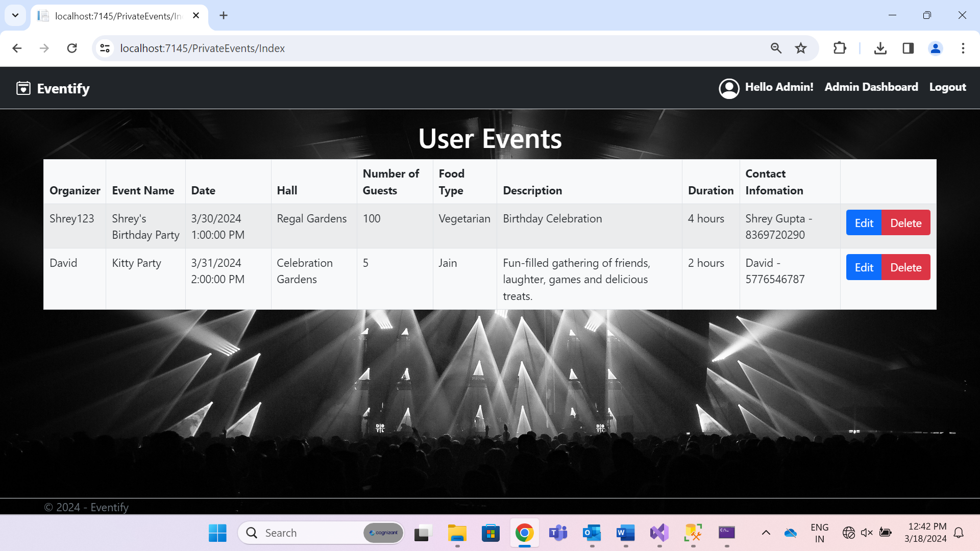

* **Manage Section:** Administrators can manage private events organized by users, edit and delete those events.

**Wireframe 9: Admin Events**

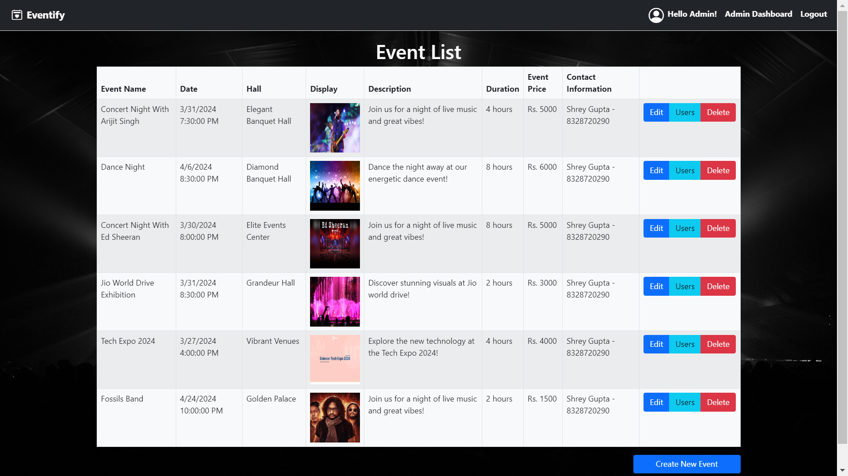

* **Manage Section:** Administrators can manage admin events, view users that bought tickets for it and can delete users and events.

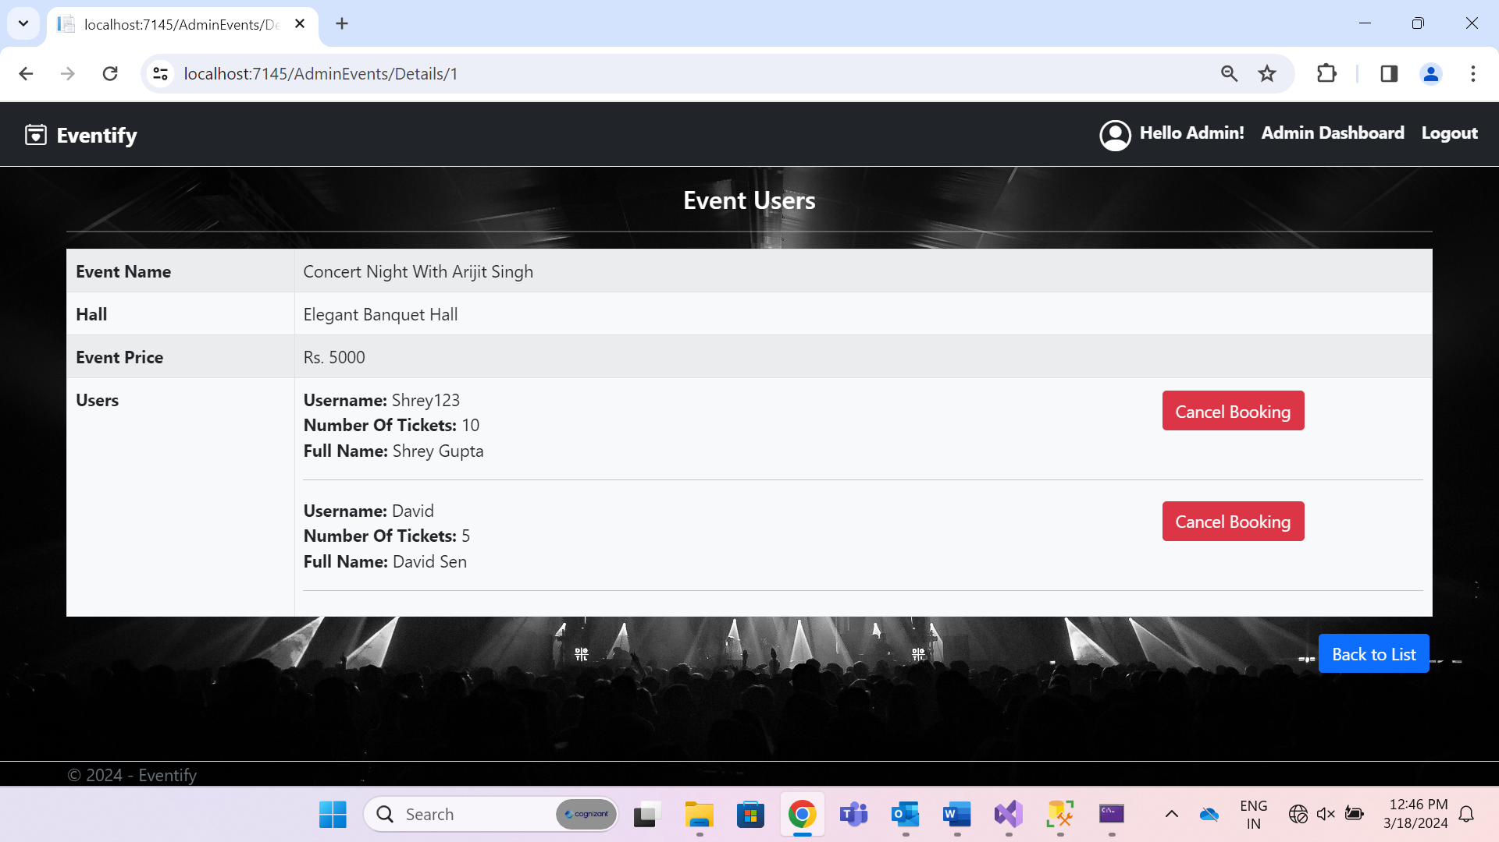

**Sprint 1: Basic Functionality**

**1. User Authentication**

* Users can register an account to access the Eventify platform.
* Users can log in to their accounts to access different features.

**2. Event Browsing**

* Users can browse events and find events of interest.
* Users can view detailed information about an event, including type, date, venue details.

**3. Event Participation**

* Users can participate in events, by buying the tickets for the event.

**Sprint 2: Advanced Functionality**

**1. Event Creation**

* Registered users can create private events, specifying details like hall, date, venue, and number of guests.
* Users can manage their account change password, phone number.

**2. Admin Features**

* Admins can manage the inventory of events, view or cancel all events.
* Admins can manage users that buy tickets for admin events view, cancel bookings.

**3. User Interaction**

* Users have personalized dashboards to track their own events and upcoming participations.



**Future Scope:**

* Integration of a secure payment gateway to facilitate seamless transactions for event bookings.
* Implementation of a cancellation feature for users to cancel their bookings within a specified time frame.
* Enhancing user experience by adding features such as event reminders, personalized recommendations based on past bookings, and social sharing options.
* Incorporating feedback mechanisms for users to provide reviews and ratings for events attended.
* Integration with social media platforms for seamless sharing of event details and user-generated content.